Ex.No.4: OFDMA Resource Block Allocation
Objective
1. To determine the Number of Resource Blocks (RBs) allocated in an OFDMA system
based on available bandwidth and system configuration.
2.To evaluate the Resource Block Utilization (%) by analyzing how efficiently available
RBs are assigned to active users.
3.To calculate the User Throughput (Mbps) based on allocated resource blocks and
modulation efficiency in the OFDMA system.

Objective 1 Matlab Code and Output:
clc; clear; close all;
% System parameters
bandwidth = 10e6; % 10 MHz
rb_size = 180e3; % 180 kHz per RB
% Total Resource Blocks
total_RB = floor(bandwidth / rb_size);
% Users
users = 1:6;
% RB allocation (simple equal + remainder distribution)
base = floor(total_RB / length(users));
alloc = base * ones(1,length(users));
alloc(1:mod(total_RB,length(users))) = alloc(1:mod(total_RB,length(users))) + 1;
utilization = (alloc / total_RB) * 100;
disp('Total Resource Blocks:')
disp(total_RB)
disp('RB Allocation per User:')
disp(alloc)
figure
% -------- Graph 1: RB Allocation per User --------
subplot(2,1,1)
stem(users, alloc, 'filled', 'LineWidth', 2)
title('OFDMA Resource Block Allocation per User')
xlabel('User Index')
ylabel('Number of Resource Blocks')
grid on
% -------- Graph 2: RB Utilization --------
subplot(2,1,2)
plot(users, utilization, '-o', 'LineWidth', 2)
title('OFDMA Resource Block Utilization (%)')
xlabel('User Index')
ylabel('Utilization (%)')
grid on
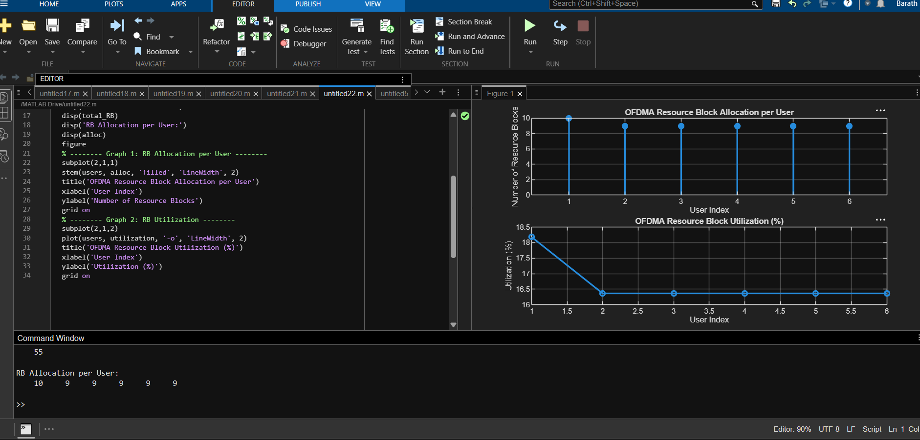

Objective 2 Matlab Code and Output:
clc; clear; close all;
% Total system resource blocks
total_RB = 50;
% Number of active users
users = 1:5;
% RB allocation to users (example scenario)
alloc = [12 10 9 8 11];
% Resource Block Utilization (%)
util = (alloc / total_RB) * 100;
disp('Resource Block Utilization (%) per User:')
disp(util')
figure
% -------- Graph 1: RB Allocation --------
subplot(2,1,1)
plot(users, alloc, '-o', 'LineWidth', 2)
title('OFDMA Resource Block Allocation per User')
xlabel('User Index')
ylabel('Number of Resource Blocks')
grid on
% -------- Graph 2: Utilization (%) --------
subplot(2,1,2)
plot(users, util, '-s', 'LineWidth', 2)
title('OFDMA Resource Block Utilization (%)')
xlabel('User Index')
ylabel('Utilization (%)')
grid on
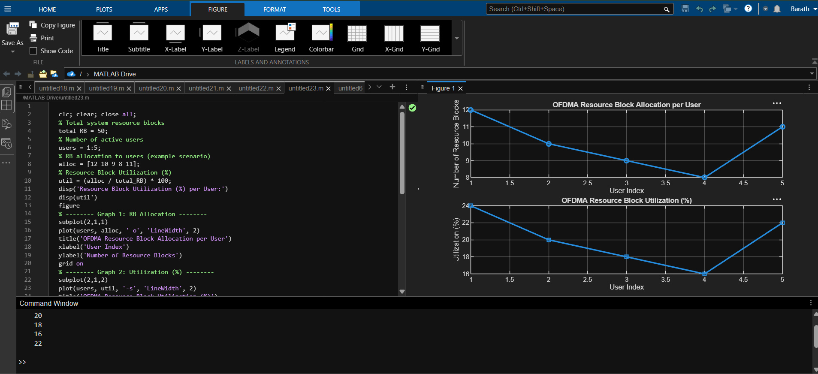
Objective 3 Matlab Code and Output:
clc; clear; close all;
% System parameters
rb_bw = 180e3; % Bandwidth per RB (180 kHz)
users = 1:5;
% Allocated Resource Blocks per user
alloc_RB = [12 10 9 8 11];
% Modulation efficiency (bits/symbol)
mod_eff = [2 4 6 4 2]; % QPSK, 16QAM, 64QAM etc.
% Throughput calculation (Mbps)
throughput = (alloc_RB .* rb_bw .* mod_eff) / 1e6;
disp('User Throughput (Mbps):')
disp(throughput')
figure
% -------- Graph 1: Throughput per User --------
subplot(2,1,1)

plot(users, throughput, '-o', 'LineWidth', 2)
title('OFDMA User Throughput')
xlabel('User Index')
ylabel('Throughput (Mbps)')
grid on
% -------- Graph 2: RB vs Throughput --------
subplot(2,1,2)
plot(alloc_RB, throughput, '-s', 'LineWidth', 2)
title('Resource Blocks vs Throughput Relationship')
xlabel('Allocated Resource Blocks')
ylabel('Throughput (Mbps)')
grid on
